Sky Go remote Test

|  |  |
| --- | --- |
| To |  |
| From |  |
| Date |  |

Recruitment: Remote test Prerequisites

These are the acceptance criteria given by a BA. We require you, as a tester to set up a framework and get these tests automated on the sky website. Please see the tests below and automate them using JavaScript or TypeScript preferably using WebdriverIO with Mocha or Cucumber. You are welcome to use any other test framework in JavaScript/TypeScript of your expertise. We will ask you about your choice in the interview.

# Note: If you do not see the below snapshots, please use private browser history (Google chrome incognito or clear Sky.com Browser History / Cookies)

**Feature:** This feature will make sure that the shop page is navigable and usable.

**Scenario:** User navigates to shop page

**Given** I am on the home page

**When** I navigate to ‘Deals’

**Then** the user should be on the <https://www.sky.com/shop/offers> page

**Note:** You will have to handle the ‘accept cookies’ in your test.

**Home page is** [**https://www.sky.com/**](https://www.sky.com/)

**It is better to clear the cookies for sky.com or clear your web page history.**

**Scenario:** User sees tiles on the shop page

**Given** I am on the [home](https://www.sky.com/shop/) page

**When** I try to sign in with invalid credentials

**Then**I should see a text saying that ‘Sorry, we did not recognise either your username or password’

**(**please see snapshot a)

**Scenario:** User sees a list of offers on the latest offers page **Given** I am on the ['https://www.sky.com/shop/'](https://www.sky.com/shop/) page

**Then** I see a list of offers with a price to it (please see snapshot b)

# For example:

***“****£27.50”, “£66.50”, “£42.50”*

*Note: Please change the offer prices if the page shows something different. Assert only the first 3 offers.*

**Feature:** This feature will make the search show the results that are determined by editorial, as well as generic searches.

**Scenario:** User sees the editorial section in specific searches

**Given** I am on the home page

**When** I search ‘sky’ in the search bar

**Then** I should see an editorial section. (Note: Editorial section is the section highlighted in snapshot c)

(note: if ‘sky’ doesn’t work you can change it to ‘tv’)

# Snapshot A

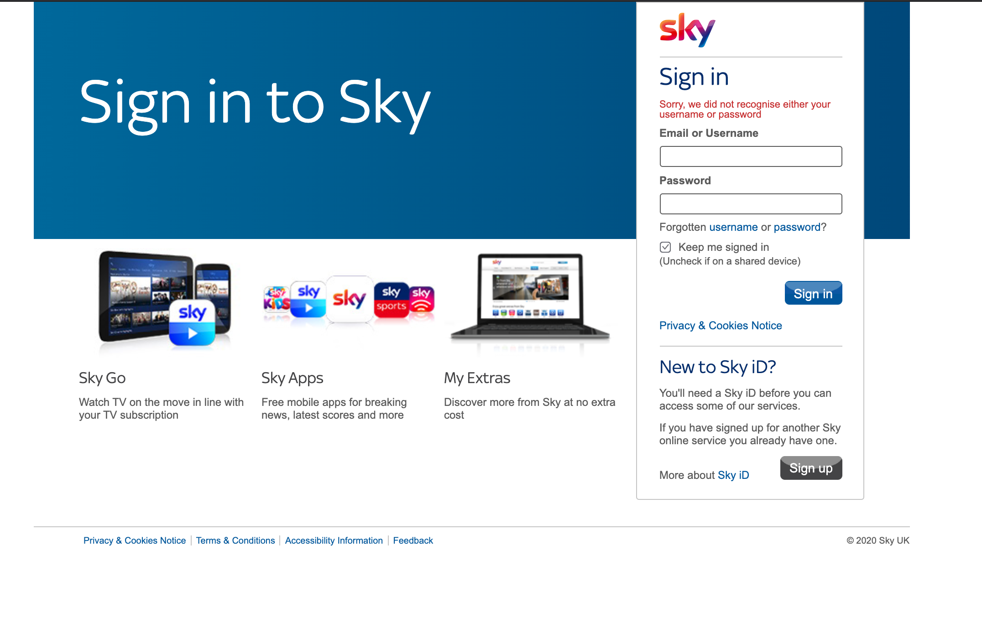

**Snapshot B**



**Snapshot C**

